Communiqué from the meeting of ARCIC III
St George’s Cathedral, Jerusalem

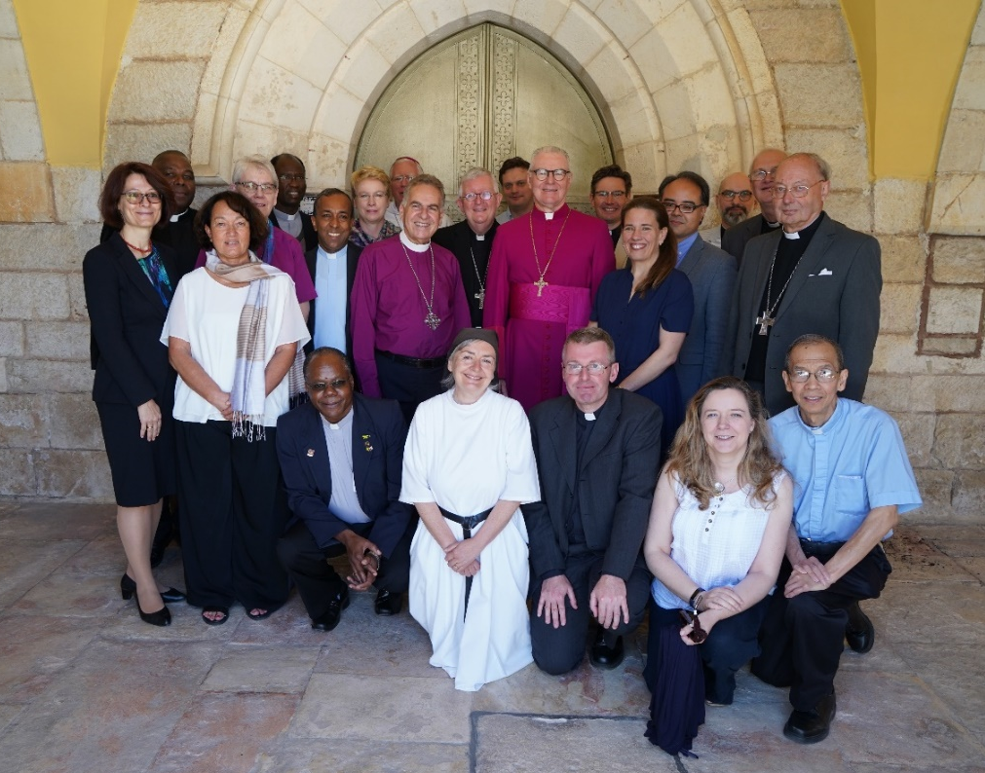

The Anglican–Roman Catholic International Commission (ARCIC) met at the Anglican Cathedral of St George, Jerusalem from 12–17 May 2019. The Commission is grateful for the hospitality afforded by the Anglican Archbishop in Jerusalem, the Most Reverend Suheil Dawani, the Dean of St George’s Cathedral, the Very Reverend Hosam Naoum and the Apostolic Administrator of the Latin Patriarchate of Jerusalem, Archbishop Pierbattista Pizzaballa OFM. Jerusalem holds a unique place in the lives and faith of all Christians and the proximity of the holy sites and prayer and worship in them undergirded the Commission’s discussions. Supremely, Jerusalem holds a unique place in the lives and faith of all Christians and the proximity of the holy sites and prayer and worship in them undergirded the Commission’s discussions. Supremely, Jerusalem is the place where our Lord Jesus Christ died and rose again, yet it is also the site of the Council of Jerusalem (Acts 15) where the apostles met for prayer and discussion under God as they addressed significant differences in the Church. Members were privileged to visit the Old City; to make a pilgrimage to Bethlehem; to visit L’École Biblique et Archéologique Française and the Ecumenical Institute at Tantur; and to meet with Heads of Churches in Jerusalem.
This year marks a transition in the life of ARCIC III after the publication of Walking Together on the Way in 2018. There have been a number of changes in both Catholic and Anglican members of the Commission, with more than half of Commission members completing their terms. The Most Reverend Sir David Moxon KNZM stood down as Anglican Co-Chair in 2018. The Most Reverend Philip Freier, Archbishop of Melbourne (Australia), replaces him as Co-Chair alongside the Catholic Co-Chair, the Most Reverend Bernard Longley, Archbishop of Birmingham (UK). Short biographies of the new members are provided below.
The agenda of the Commission now turns from the study of ecclesiology to the study of the manner in which ethical teaching is discerned in our Churches. This topic forms the second part of the mandate given to the Commission by Pope Benedict XVI and Archbishop Rowan Williams in 2009. At this meeting the Commission considered how each of the two communions had discerned their ethical teaching with reference to two case studies: slavery and contraception. The Commission also discussed how this new phase of work related to Walking Together on the Way, and in particular the determining method of that document, Receptive Ecumenism. In light of these discussions the Commission further developed the agenda and plans for its ongoing work.
New Members (Anglican)

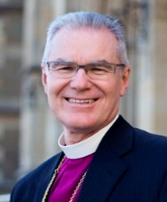
The Most Reverend Dr Philip Freier is Archbishop of Melbourne and Primate of the Anglican Church of Australia. He grew up in a working class suburb of Brisbane, and trained as a teacher. He experienced a powerful conversion to Christ while working with indigenous Christians in North Queensland - where he also met his wife, Joy, and decided to seek ordination. He was ordained a priest in 1984 and a bishop in 1999. Archbishop Freier has been Archbishop of Melbourne since December 2006, and Primate since July 2014. In 2000 he completed a PhD at James Cook University with a thesis on ‘Living with the Munpitch: The History of Mitchell River Mission, 1905-1967’.

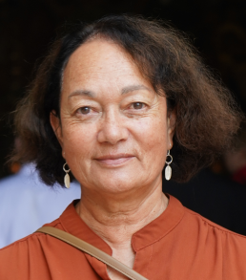
Dr Moeawa Callaghan is a former lecturer in Practical Theology and Kaiwhakahaere (Coordinator/Lecturer) of the Indigenous Programme at Laidlaw College and the College of St John the Evangelist, Auckland, New Zealand. She has taught indigenous and majority world Christologies, theologies and praxis methodologies. Her background is in Practical Theology, Christian Thought, and Maori and Indigenous Theology. She obtained a PhD in Theology in 2011, and has been a member of the Anglican–Roman Catholic Dialogue of New Zealand. In addition to Practical and Indigenous Theology, her interests in ethics are in the areas of race, culture, and marginalization.

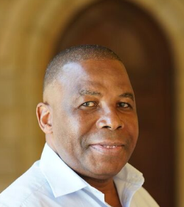
The Reverend Dr Revd Isaias Ezequiel Chachine was born in Southern Mozambique, and studied theology at the University of Pietermaritzburg, obtaining a doctorate in theological ethics at the University of Uppsala, Sweden. He currently serves as Anglican Chaplain to the University of Cape Town. He has taught theological ethics at the College of the Transfiguration, Grahamstown, Eastern Cape, and at Rhodes University.

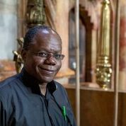
The Reverend Canon Garth Minott is a priest of the Diocese of Jamaica and the Cayman Islands. He has previous experience of international bilateral dialogue from the Anglican–Methodist International Commission on Unity and Mission (AMICUM) where his contribution was much appreciated. Canon Minott is a parish priest, and also serves as the Anglican Warden at the United Theological College of the West Indies, where he is also Lecturer in Christian Ethics and Pastoral Studies.

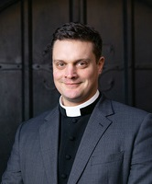
The Reverend Dr Alexander Ross is a priest in the Anglican Church of Australia, and formerly Associate Dean of Emmanuel College, Cambridge. He has recently completed his doctorate at the University of Cambridge as a Commonwealth Scholar under the supervision of former Archbishop of Canterbury, Dr Rowan Williams. His research, which he is currently working up for publication as a book, concerns the structure of the worldwide Anglican Communion, and particularly the place of metropolitical authority and the ecclesial province within its polity.

New Members (Catholic)

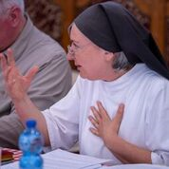
Sister Margaret Atkins, OSA is a member of the community of Augustinian Canonesses at Boarbank Hall in Cumbria. She is also a Research Fellow at Blackfriars, Oxford. She was previously a Senior Lecturer in Theology at Trinity and All Saints College, Leeds. She has translated Cicero, St Augustine and St Thomas Aquinas, and has particular interests in virtue ethics, in the ethics of healthcare and of the environment, and in St Augustine. She has recently served as temporary Academic Tutor at the Venerable English College and taught moral theology at Oscott College.

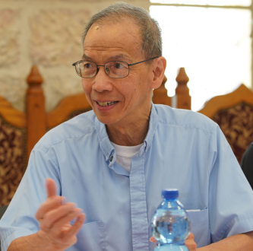
Fr Albino Barrera, OP is Professor of Theology and Economics at Providence College (Rhode Island, USA). A native of the Philippines, he studied engineering at De La Salle University (Manila) and earned his PhD in economics from Yale University and his licentiate in sacred theology (STL) from the Pontifical Faculty of the Immaculate Conception (Washington DC). He has taught and published in the fields of Catholic social thought, religion and development, economic ethics, globalization, and economic development.

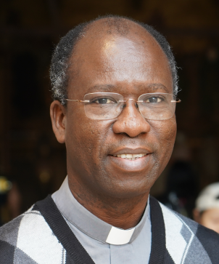
Fr Paul Béré, SJ, was born in Burkina Faso, and teaches at the Biblicum in Rome. He was formerly an Old Testament professor at Institut de Théologie de la Compagnie de Jésus, Abidjan, Côte d’Ivoire. His field of expertise is the Hebrew Bible. His doctoral research in biblical sciences at the Pontifical Biblical Institute looked at the figure of Joshua in the eponymous book (2007). He has been developing an understanding of the functioning of (written) texts in oral/aural contexts. He has been a peritus at the synods on the Word of God and for Africa, and he is a consultor for a number of Vatican dicasteries, including the Pontifical Council for Culture.

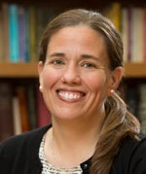
Professor Kristin Colberg studied first at Notre Dame, and then spent two years in Belize City, Belize, as a part of the Jesuit Volunteer Corps before pursuing a Master's of Divinity at Yale Divinity School. Her doctoral work focused on systematic theology with an emphasis in ecclesiology. Her dissertation examined the relationship between Vatican I and Vatican II. Her theological work is rooted in a desire to demonstrate the Church’s ability to speak meaningfully in the modern context. She is the author of Vatican I and Vatican II: Councils in the Living Tradition, as well as an edited volume, The Theology of Cardinal Walter Kasper: Doing Truth in Love, and numerous scholarly articles on Vatican II, ecumenism and major developments in Catholic thought. She is a member of the official Reformed-Catholic dialogue in the United States.

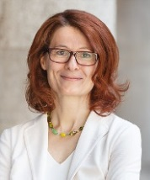
Professor Sigrid Müller is a professor of Moral Theology at the Catholic Theological Faculty at the University of Vienna (Austria) where she was formerly Vice Dean for Research. She studied Theology, Latin and Italian at Tübingen and at the Pontifical Gregorian University at Rome, and also holds a Master’s degree in Family Counselling from the Catholic University of Salamanca. Her special research interests are the history of moral theology and bioethics with a focus on the ethics of technology. In 2008 she was appointed a Junior Member of the Austrian Academy of Sciences and a member of the Curatorial Board of the Austrian Science Fund FWF. She was the president of the European Society for Catholic Theology from 2011–2013.

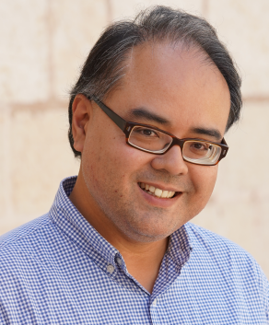
Dr Emmanuel Nathan is Associate Dean of Research of the School of Theology at the Faculty of Theology and Philosophy, Australian Catholic University (ACU). Based in Sydney, he is also a lecturer in biblical studies, a member of the faculty’s Interreligious Dialogue Network, and coordinator of the short courses in theology for Sydney and NSW. He is an adjunct member of ACU’s La Salle Academy for Faith Formation and Religious Education, serves as an external member of the Academic Board of the Catholic Institute of Sydney, and serves on the advisory board of the ACU Centre for Liturgy. He holds a PhD (Sacrae Theologiae Doctor) from the Catholic University of Leuven in Belgium. He is a member of the Society of Biblical Literature, the European Association of Biblical Studies, and the Centre Interuniversitaire d’Etudes Judaïques, Belgique (Institutum Iudaicum).
Appendix: Members of ARCIC III

Co-Chairs
The Most Reverend Dr Philip Freier, Archbishop of Melbourne, Australia;
The Most Reverend Bernard Longley, Archbishop of Birmingham, England.

Anglican Members
Dr Moeawa Callaghan (The Anglican Church Church in Aotearoa, New Zealand and Polynesia);
The Reverend Dr Isaias Ezequiel Chachine (The Anglican Church of Southern Africa);
Dr Paula Gooder (The Church of England);
The Reverend Canon Garth Minott (The Church of the Province of the West Indies);
The Right Reverend Linda Nicholls (The Anglican Church of Canada);
The Reverend Dr Alexander Ross (The Anglican Church of Australia);
The Reverend Dr Peter Sedgwick (The Church in Wales).

Consultant
The Right Reverend Christopher Hill KCVO (The Church of England).

Catholic Members
Sister Margaret Atkins OSA (Boarbank Hall, England);
The Reverend Albino Barrera OP (Providence College, RI, USA);
The Reverend Paul Béré SJ (Pontifical Biblical Institute, Rome);
The Most Reverend Robert F Christian OP (Auxiliary Bishop, San Francisco, CA, USA);
Dr Kristin Colberg (St John’s University, Collegeville, MN, USA);
Professor Sigrid Müller (University of Vienna, Austria);
Dr Emmanuel Nathan (Australian Catholic University);
The Reverend Vimal Tirimanna CSsR (Pontifical Academia Alfonsiana, Rome).

Consultant
Professor Paul Murray (University of Durham, England).

WCC Consultant
Professor Dr Myriam Wijlens (University of Erfurt, Germany).

Staff
The work of the Commission was supported by the two co-secretaries:
The Reverend Anthony Currer (Pontifical Council for Promoting Christian Unity);
The Reverend Dr William Adam (Lambeth Palace);

and

The Reverend Neil Vigers (Anglican Communion Office);
The Venerable Jonathan Gough.

